Predicate Nominative as a Subject Complement

✅ What Is a Predicate Nominative as a Subject Complement?
# Source: AI Source: Provided by: [Data Path: Persons Table -> ID Column: 1, Name_En Column: Motasem Essam] -> From: [ChatGPT] on [8/4/2025]
A predicate nominative (also called predicate noun) is a noun or pronoun that follows a linking verb and renames or identifies the subject. It is a type of subject complement because it completes the subject by giving it another name or identity.

🔸 Key Features:
# Source: AI Source: Provided by: [Data Path: Persons Table -> ID Column: 1, Name_En Column: Motasem Essam] -> From: [ChatGPT] on [8/4/2025]
- Follows a linking verb (e.g., is, are, was, were, become, seem)
- Is a noun or pronoun
- Renames or defines the subject
- Subject = Predicate Nominative

🔸 Examples of Predicate Nominative as Subject Complement:
# Source: AI Source: Provided by: [Data Path: Persons Table -> ID Column: 1, Name_En Column: Motasem Essam] -> From: [ChatGPT] on [8/4/2025]
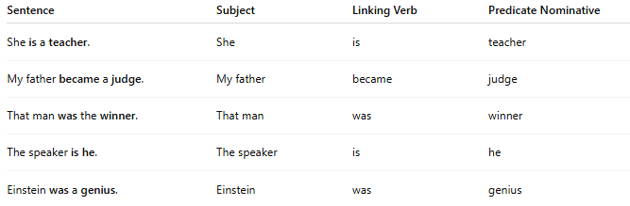
Sentence | Subject | Linking Verb | Predicate Nominative
She is a teacher. | She | is | teacher
My father became a judge. | My father | became | judge
That man was the winner. | That man | was | winner
The speaker is he. | The speaker | is | he
Einstein was a genius. | Einstein | was | genius

🔸 How to Identify:
# Source: AI Source: Provided by: [Data Path: Persons Table -> ID Column: 1, Name_En Column: Motasem Essam] -> From: [ChatGPT] on [8/4/2025]
Ask:
- What is the subject?
- What is the subject equal to (after the linking verb)?
If the answer is a noun or pronoun that renames the subject, it’s a predicate nominative.

